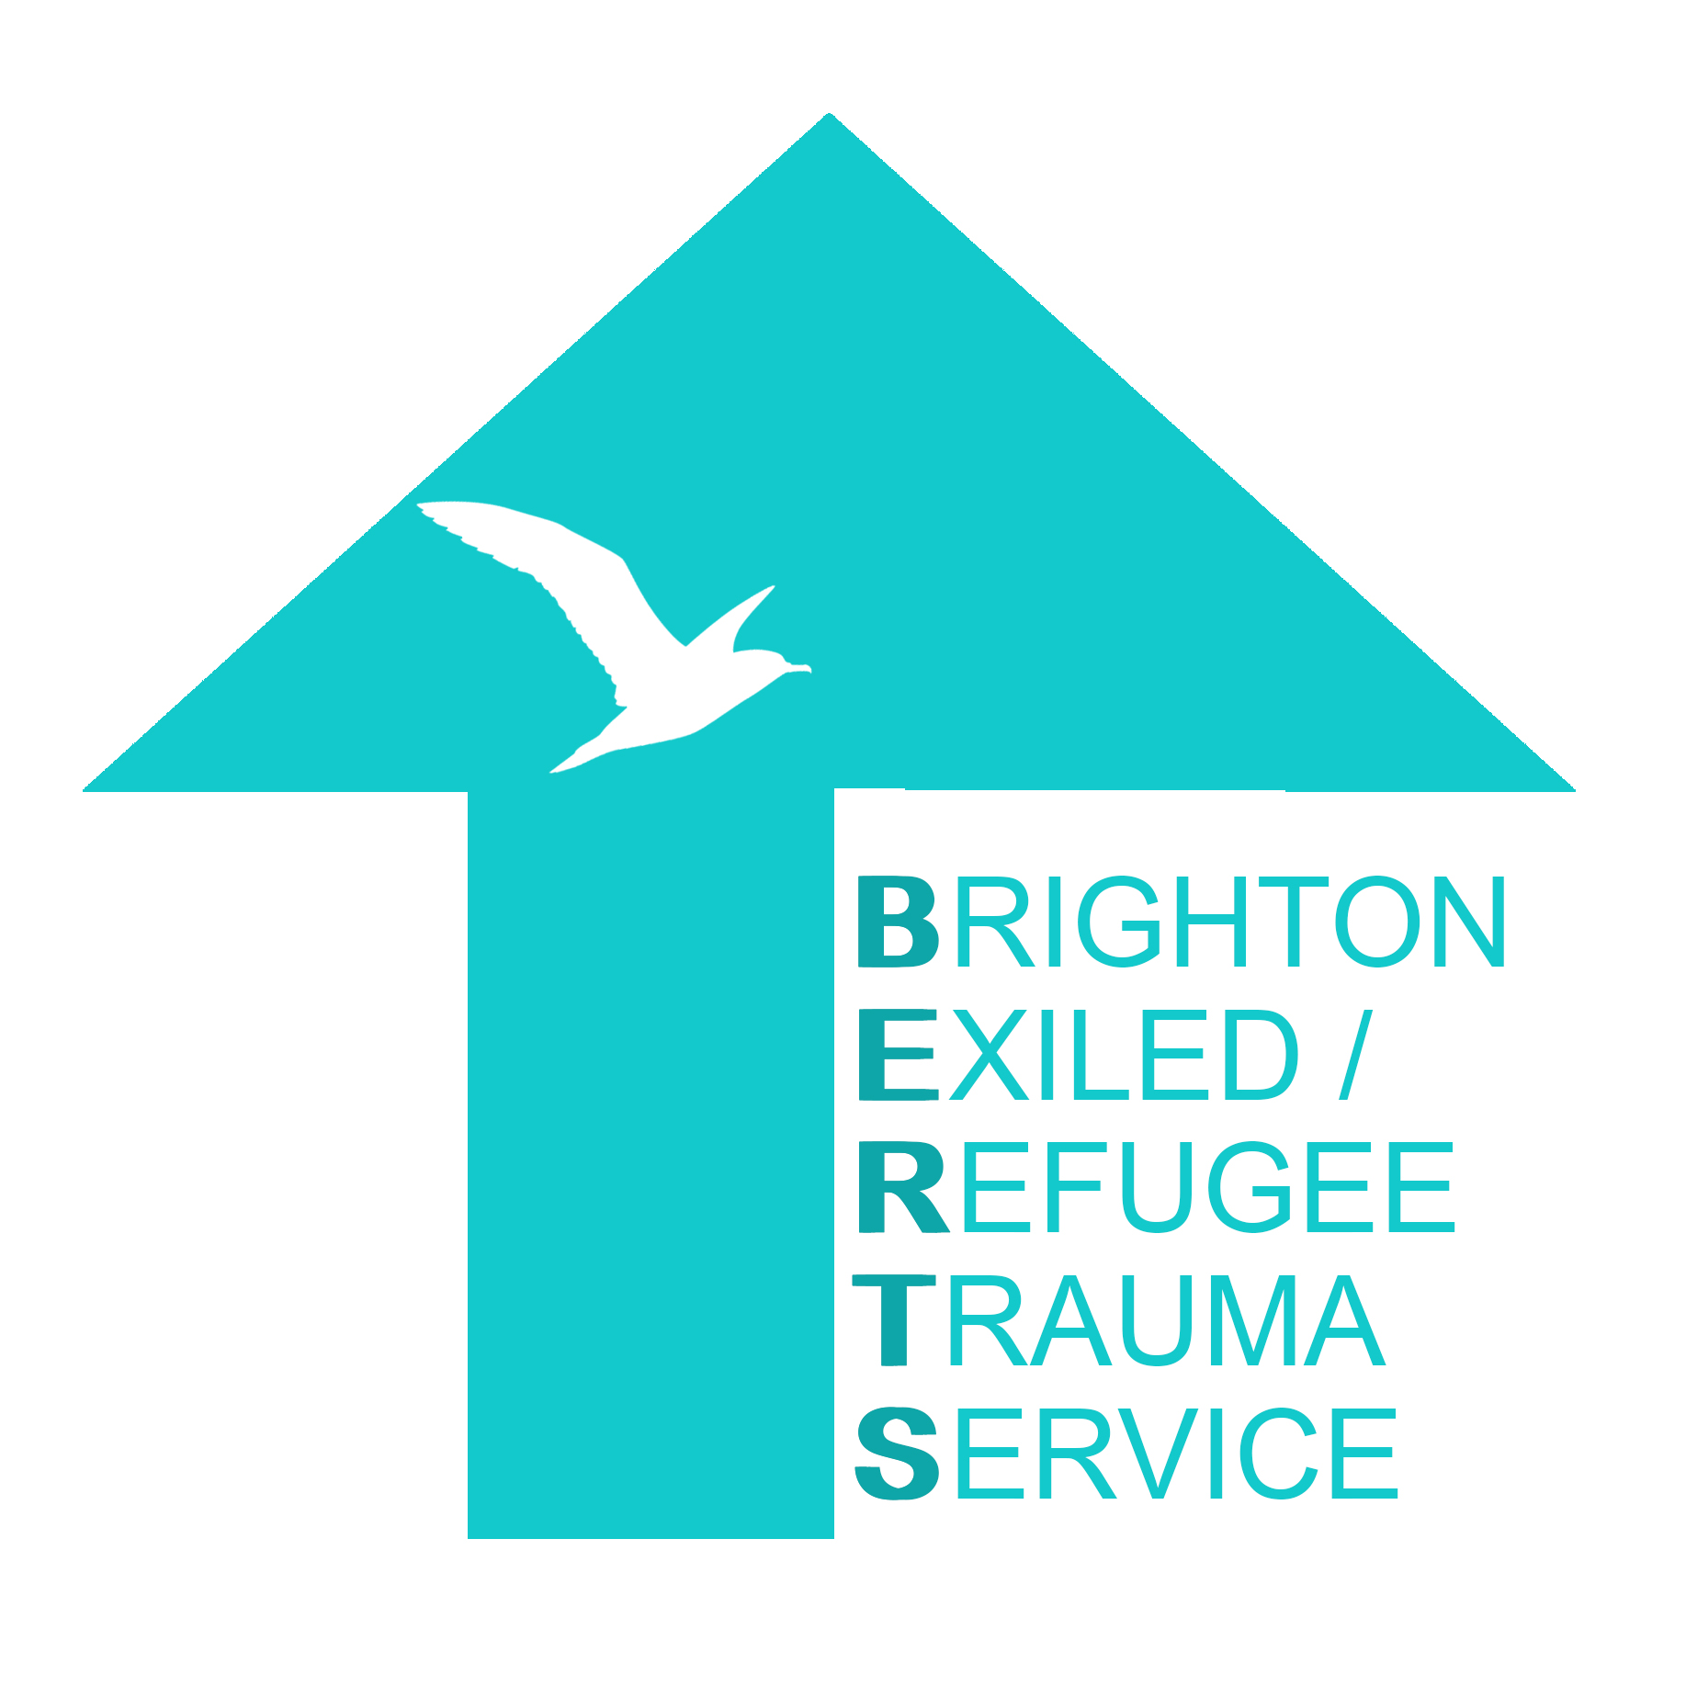

Brighton Exiled / Refugee Trauma Service (BERTS) is part of Brighton and Hove CBT

CLIENT REFERRAL FORM

Name of client: _______________________
(please check all spelling is correct)

CRITERIA FOR REFERRAL
Is an interpreter required? Yes/No
Please note that we only provide treatment in English. If your client is not able to conduct therapy fluently in English we recommend interim psychosocial support and language support until they are able to do so, at which point please re-refer. They must be fluent in English and able to fully converse (hold a conversation in English) before being referred to BERTS for psychotherapy/psychological treatment. We recommend ESOL courses at Brighton Metropolitan College and/or referral to Migrant English Project in the meantime.

Has this referral been completed jointly with the client? Yes/No
(If no, please ensure you do this, and explain that we offer mental health treatment and that we will be in touch by phone/text/email/whatsapp).

Is the client an asylum seeker or have they been given temporary Leave to Remain? Yes/No
Please note that if the client has lived in the UK for more than 10 years and has permanent leave to remain, they should be treated within statutory services/NHS, as any British citizen. BERTS is a service for asylum seekers and recent refugees although we do make exceptions if the waiting list is short – check by phoning Sally on 07961779010.

Does the client wish to have a support worker Yes/No
A support worker is provided for isolated/vulnerable clients whilst they wait for psychotherapy/psychological treatment; this is a volunteer befriending service, usually for 1 hour per week.

-------------------------------------------------------------------------------------------------------
If you are unsure whether to refer a client or not, or wish to discuss a potential referral in order to ascertain what the current wait times are and also if the client is suitable for BERTS, in the first instance please email our Clinical Director with your phone number and she will call you back:
s.r.munt@sussex.ac.uk
sally@brightonandhovecbt.com
Please complete all details:

REFERRER DETAILS
Name of referrer and job title:

Practice/Agency/Organisation:

Your Telephone number:

Your email:

Date of referral:

CLIENT DETAILS

Name of client:

Address:

Client’s Telephone number:

Client’s email:

Client’s Date of Birth:

Approximate date of arrival in the UK:

EQUALITY & DIVERSITY INFORMATION

Gender Female/Male/Trans/Other/Prefer Not to Say

Sexual Orientation LGBTQI or Heterosexual

Country of origin:

Ethnicity (eg. minority identity):

First Language:

Other languages spoken fluently including English:

No Recourse To Public Funds? Y/N

Street Homeless Y/N
Living in temporary accommodation (eg asylum hotel, hostel) Y/N
Permanently housed Y/N

SAFEGUARDING

Does this person live with a carer? If so please supply any relevant information:

Does this person have a social worker or key worker Yes/No
Please provide their name and organisation

NHS GP’s name and address:
(this information must be provided)

Have you informed the GP? Yes(Y) No(N)

Is there any risk of harm to the client themselves, or a risk of harm to others? Any history of violence?

Is there any forensic history? Either as your client as perpetrator of a crime or as victim of a crime?

Is your client suicidal? We have a waiting list of several months. If your client has any kind of suicidal intent then please refer them to the Mental Health Rapid Response Service
https://www.sussexpartnership.nhs.uk/our-services/community-based-services/mental-health-rapid-response-service
Brighton & Hove Tel: 0300 304 0078 (24 hours a day, 7 days a week)

MENTAL HEALTH
Is this client involved with any other mental health agencies for these problems? (eg. Local NHS Mental Health Team, Mind Counselling Service, Samaritans, Other Psychological Services including NHS Psychiatrist):

Clinical Symptoms

Feeling very sad Tick ( )
Finding it hard to stop thinking about past problems ( )
Feeling very lonely ( )

Wanting to keep away from other people ( )
Getting angry very easy ( )

Feeling scared ( )
Problems falling asleep ( )
Waking up a lot in the night ( )
Nightmares ( )

Finding it hard to concentrate ( )
Not remembering things ( )

Other – please detail:

Duration of the problem:

What medication has been prescribed?:
(please include dose if known)

Relevant psychiatric, social or medical history in UK or in previous country of residence, including any previous diagnosis or any mental health treatment by a health professional in the country of origin or in the UK:

Does the client have any physical illness or injuries, particularly if linked to their experience as a refugee/asylum seeker? Does the client have a physical disability?

How isolated is the client? Do they have friends or family or neighbours in the UK that they can talk to, is this client in touch with any of the national refugee community groups or relevant religious or ethnic groups locally?
If yes, provide name of the group:

Please provide further comments relevant to their prior experiences in country of origin, and their asylum journey, forced migration, detention in UK Immigration Centre, family status, or anything else you think relevant to a mental health referral that will help us understand how best to place them for treatment and support:

Signed:

Once completed please return this form as a single Microsoft Word document by email to:
sally@brightonandhovecbt.com
or
s.r.munt@sussex.ac.uk

Please save the Word document with this title
BERTS REFERRAL [CLIENTS NAME] [DATE OF BIRTH]

And also put the same information in the email subject line, as follows:

Confidential BERTS REFERRAL [CLIENTS NAME] [DATE OF BIRTH]

Please note that any referral sent in the incorrect format will be returned to you to resend as stipulated above. We need this for our data systems. Thank you.

If you are unsure of any details or wish to discuss please email or call 07961 779010

